**Table of Contents**

Agile Scrum Development 2

Introduction to the Problem 2

Project Overview 2

1. Details of Open-Source Project 2

1.1 Project Outline 2

1.2 Details of Contribution 3

2. Scrum Logs 3

2.1 Details of Standup Meetings 3

Sprint Logs 4

3 GitHub Logs 5

4 Critical Reflection of Use of Scrum Concerning Open Source 5

4.1 Introduction 5

4.2 Critique on Selected Project 5

4.3 Allocation Rules in Project 6

4.3 Impact of Scrum Methodology on the Project 6

4.4 Personal Reflection on Contribution to the Project 6

5 Social & Ethical Implications of Open-Source Development 6

5.1 Difference of Project from Proprietary Software 6

5.2 Social and ethical implications of Open-Source Development 7

# **Agile Scrum Development**

## **Introduction to the Problem**

Agile Scrum is a project management system that emphasizes incremental and iterative development, teamwork, and constant feedback. The Scrum technique is a common Agile implementation that focuses on breaking work down into tiny, manageable chunks called sprints. Each sprint's goal is to provide a working product increment that meets the needs of the customer. Scrum promotes regular and open communication among team members and stakeholders, including customers and end users, to guarantee that the product satisfies their requirements. The Scrum framework is made up of roles, events, and artefacts that give the development process structure and transparency. Teams that use Agile Scrum can swiftly react to changes in requirements and create high-quality solutions that meet the needs of their customers.

## **Project Overview**

The School Management System is a software project that intends to provide a comprehensive and effective solution for managing different school-related activities such as courses, tests, exam results, notice boards, timetables, students, subjects, teachers, and users. The project will be built using the Agile Scrum process to guarantee that the software is provided iteratively and incrementally, with an emphasis on constant feedback and improvement. A product backlog will be created for the project, which will prioritize demands based on their urgency and significance. Sprints will be used by the Scrum team to create and provide working software that satisfies the objectives and goals of the project. The School Management System will include a user-friendly interface that allows users to easily and efficiently manage the system, ensuring that all stakeholders, including parents, kids, and instructors, are kept up to date with important information.

## **1. Details of Open-Source Project**

### **1.1 Project Outline**

The project based on school management system in which multiple functional requirements are given and managed related to the actors and modules of system such as class, students, notice board, etc. Given below is a brief outline:

* **Project Name:** School Management System
* **Methodology:** Agile Scrum
* **Objective:** Development of a software solution for managing activities in schools
* **Requirements:**
  + Class Management
  + Student Management
  + Exam Management
  + Exam Result Management
  + Notice Board Management
  + Parent Management Module
  + Schedule Management
  + Subject Management
  + Teacher Management
  + User Management
* Sprint Plan
  + Sprint 1: Setting Up the System
  + Sprint 2: Core Functionality
  + Sprint 3: Exam & Result Management
  + Sprint 4: Notice Board & Parent Management
  + Sprint 5: Testing of System
* **Tools:** Jira used for Project Management
* Reports & Metrics such as bar charts, burnup chart

### **1.2 Details of Contribution**

Multiple needs had previously been implemented after accessing the project via an open-source portal such as GitHub. For this assessment, some additional functionalities are also implemented, such as adding a functionality of announcement module, in which a parent or student may visualize the notice board. I contributed a functionality to view announcements on notice board, which will benefit both student and parents about upcoming events on school. Moreover, it will also help parents in case of any emergency.

## **2. Scrum Logs**

This section includes scrum logs, i.e., details of standup meetings and spring logs which were applied to the project to manage and complete it within time.

### **2.1 Details of Standup Meetings**

Date: 6 May, 2023

Time: 11:00 AM

Attendees

* Harpreet Dhaliwal
* Harpreet
* Vipal
* Pareet
* Aman Preet

**Agenda:** Update on Announcements Module

Four people attended a stand-up meeting on May 6, 2023, at 11 a.m., with the agenda being a product update on the announcement’s module. Harpreet inquired about the status and development of the project on the parent module and proposed some additional strategies to complete the tasks on time. Pareet questioned about the next stages, and Aman explained her idea to provide the functionality for parents and children to read the notice board announcements. Potential project challenges were mentioned, such as the need for feedback from the entire team and the necessity for consistent progress. The team committed to address these challenges and achieve a significant outcome.

### **Sprint Logs**

Below are the logs that were attained after completing the sprint on parent management module. The project management of this assessment was held using Jira Tool.

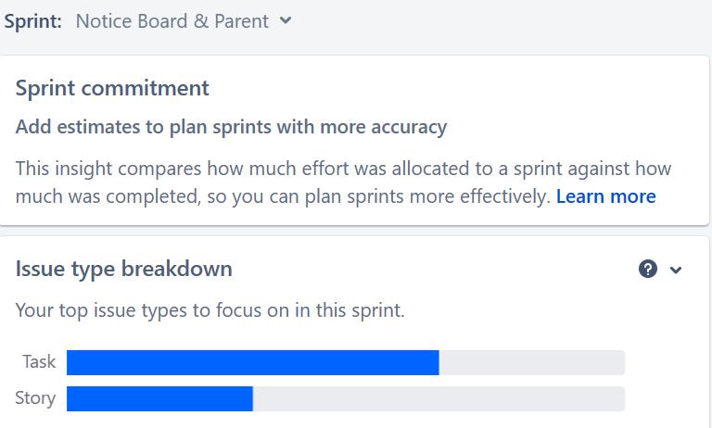

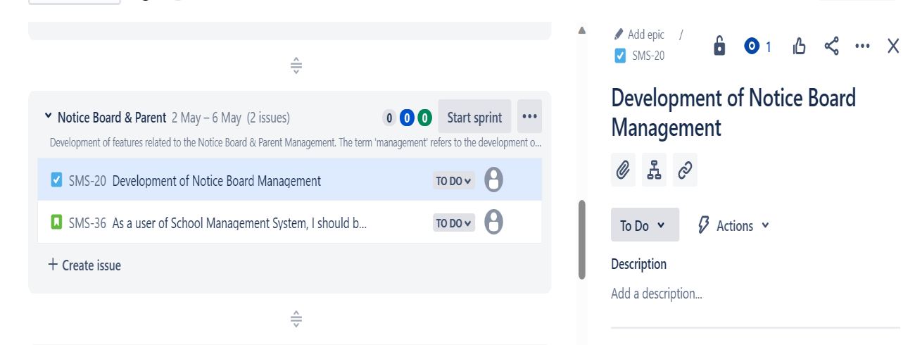

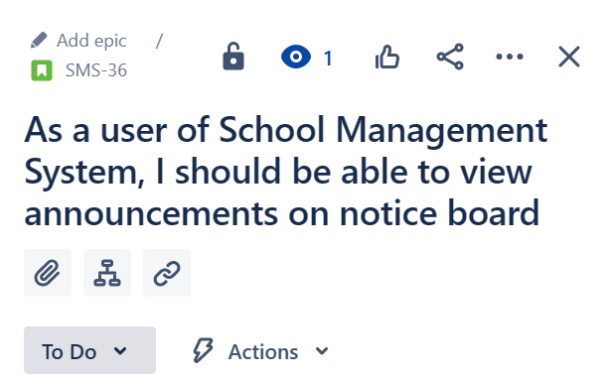

## **3 GitHub Logs**

As the project was successful it had liquid therefore commitments and changes were made in the code for this assessment. Given below is a list of commits and changes that were made:

* Accessing the Project on GitHub
* Loading the Project in GitHub & Making Changes to the Code
* Adding a functionality of Parent Module in Project
* Committing and Saving the Changes to the code

## **4 Critical Reflection of Use of Scrum Concerning Open Source**

### **4.1 Introduction**

Scrum and other agile approaches are becoming more popular amongst software development teams and open-source projects. This reflective analysis looks at how Scrum was implemented in an open-source project, with a special emphasis on the consequences of role allocation. This paper also evaluates the selected open-source project before finishing with a personal comment on the contributions made to said project.

**4.2 Critique on Selected Project**

The open-source initiative chosen is a web-based platform that promises to provide schools with a flexible and extendable solution. The software's codebase was rigorously organized, modularized, and properly documented, making it easier for beginner developers who may wish to assist in the project to understand. Nonetheless, the proposal suffered from ambiguity in its vision and product roadmap, as well as deficiencies such as parent management tools that need be included. Managing code versions was tough, as was combining contributions given by multiple programmers during development reviews.

**4.3 Allocation Rules in Project**

With five members in a group, project development was assigned to all members, including multiple requirements such as parent management module testing of the system and one more requirement, the strip, which was assigned to group members as needed. The development team bosses are in charge of adding functionalities, fixing defects, and generating error-free code for system development.

**4.3 Impact of Scrum Methodology on the Project**

The use of scrum in the open-source initiative resulted in positive effects for its progress. The scrum technique was implemented, which promoted increased cooperation and communication among team members, increased visibility and responsibility, and provided a structure for step-by-step advancement and continuous improvement. Furthermore, role allocation aided in efficient project management while keeping an uncompromising commitment to end-user satisfaction.

**4.4 Personal Reflection on Contribution to the Project**

As a participant in the open-source movement, I witnessed considerable benefits from applying scrum. Sprint planning, daily standups, and retrospective meetings established a clear framework for task organisation and progress tracking. Furthermore, the assignment of responsibilities encouraged accountability while encouraging common understanding of project objectives and priorities among team members. Finally, employing scrum approach resulted in improved development methods as well as encouraging collaborative teamwork within an efficient working atmosphere.

**5 Social & Ethical Implications of Open-Source Development**

**5.1 Difference of Project from Proprietary Software**

This project differs from proprietary software development in following ways:

* Source Code Access
  + Open-source software initiatives allow users to access and modify the underlying source code, whereas proprietary software initiatives keep the source code hidden and out of reach of users.
* Community-Driven Development:
  + The advancement of open-source software is frequently the result of collaborative efforts by people from all over the world to improve and upgrade the software. Private software development, on the other hand, usually involves a specific group or entity.
* Licensing
  + Open-source software initiatives frequently include licencing provisions that allow users to freely use, distribute, and modify the software. In contrast, proprietary software is typically available under a fee-based license with usage and distribution restrictions.

**5.2 Social and ethical implications of Open-Source Development**

The use of open-source development can have a wide range of effects on software companies of all sizes. For smaller businesses, open-source platforms' access to a large collection of resources, such as code libraries, frameworks, and development tools, allows them to develop software at a lower cost and in less time than proprietary options. The community-driven approach also provides access to global developers who may contribute to small businesses' projects. However, these advantages may be accompanied by risks, as larger firms may replicate their initiatives, resulting in competition for smaller entities. Large-scale software companies, on the other hand, can use open-source approaches to accelerate innovation while lowering R&D costs. Open-source schemes can also be used to find talent resourcing or co - operation opportunities.